Galderma Quarterly PTR Staging Area

User Documentation
Version 1.0


Contents
1 Document control 3
1.1 About this document 3
1.2 Changes made to this document 3
1.3 Purpose of this document 3
1.4 Audience for this document 3
2 Assumptions and constraints 4
3 Monthly Data 5
3.1 Galderma PROCESS 6
3.1.1 Process steps 6
4 QC 8
5 Appendices 16
5.1 Appendix A1: Download FTP Information 16
5.2 Appendix A2: Download Server Information 16
5.3 Appendix A3:Processing Server Information 16
5.4 Appendix A4: File Express Information 16

Document control

About this document
Author | Anika Nower
Published
File location
Status
Confidentiality | This document is confidential and must not be distributed outside of IMS Health.
Copyright | © 2026 IMS Health Incorporated or its affiliates. All rights reserved.

Changes made to this document

Version | Sections changed or created | Date of change | Author or contributor name | Role | Change summary
 |  | August, 12 | Anika Nower

Purpose of this document
The purpose of this document is to describe Galderma Monthly PTR Staging area.

Audience for this document
This document has been written for:
- Production team members

Assumptions and constraints

ID | Assumptions

ID | Constraints

Monthly Data
Step# | Step Description
Mail come from
From: Puttegowda, Shailesh B. (Bangalore)
To: Iglesias, Jérome (Paris)
Cc: Pillay, Marshall (London); Gautier, Jean-Marc (Paris); Shiro, Karine (Paris); Zarrouk, David (Paris); Consumer Health Production (IMS London)
Subject: Latest Month(YMM) Galderma PTRI Database
Hi Jerome,
Please find the 12M05 Galderma PTRI database in the following location.
ftp://ftp-emea.rxcorp.com/Level1_PTRi/Client/
Database name: GALDER_12M05.zip
Username: D08044
Password: CHProd
“Please use Windows Explorer to access the ftp site given above. The link will not work using Internet Explorer.”
Thanks & regards
Shailesh
Consumer Health Production

The information contained in this communication is confidential and is intended only for the use of the recipient named above. If the reader of this message is not the intended recipient, you are hereby notified that any dissemination,distribution, or copying of this communication is strictly prohibited. If you have received this communication in error, please re-send this communication to the sender and delete the original message or any copy of it from your computer system. Thank You.

IMS Health Ltd, a company registered in the UK, registered address 7 Harewood Avenue, London
NW1 6JB, registration number: 00634325
 | Log in to filezilla using Credential at Appendix A1

Galderma PROCESS

Process steps
Step | Action
1 | Log on to the server using Appendix A3
2 | Download the zip file to the following location:  D:\CustomData\Galderma_midas_feed\Input\Quarterly\Quarterly PTR\
3 | Unzip file using Extract to zipfile name.  [For example: GALDER_12M05.zip as GALDER_12M05]
4 | Rename the unzip folder M01.  [For example: GALDER_12M05 as M01]
5 | Go to: D:\CustomData\Galderma_midas_feed\Tools\windump
6 | Run Windump32.exe  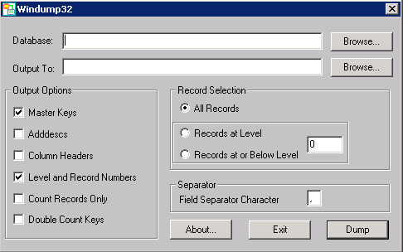
7 | Browse Database  D:\CustomData\Galderma_midas_feed\Input\Quarterly\Quarterly PTR \M01\.PRM  Browse Output To: D:\CustomData\Galderma_midas_feed\Input\Quarterly\Quarterly PTR \M01\M01.txt  Check Master Keys, Adddescs, Column Headers  Select records at level 15(less one from attribute, after checking .prm file using system utilities)  Separator ‘|’
8 | Click Dump
9 | Go to: D:\CustomData\Galderma_midas_feed\SSIS\galderma_midas_feed_PTR(both)
10 | Open galderma_midas_feed.sln
11 | Run QUARTERLY.dtsx package
12 | Output file IMS_GALDERMA_PTR_FF_Mmmyy.txt will generate on following location:  D:\CustomData\Galderma_midas_feed\Output\Quarterly\Quarterly PTR
13 | Rename the file mm with latest month and yy with latest year.  [for example IMS_GALDERMA_PTR_FF_Mmmyy.txt as IMS_GALDERMA_PTR_FF_M0512.txt]
14 | Zip the txt file  [for example IMS_GALDERMA_PTR_FF_ M0512.txt as IMS_GALDERMA_PTR_FF_M0512.zip]
15 | Backup the txt and zip file in one folder with name the latest period.
16 | For delivery:  Log in to server using Appendix A4 to Appendix A2
17 | Copy the file from \\162.44.22.161\d$  Select Favorite Products →IMS File Express Administration → Add new file→browse select the output zip file.  Template :Galderma  File description: Quarterly PTR delivery for Mmm/YY MIDAS Monthly data  Save all.
20 | Go to D:\CustomData\Galderma_midas_feed\Input\ Quarterly \ Quarterly PTR\Old  Create a New folder named MmmYYYY  [For example, the folder name M042012]
21 | Take backup of the files in D:\CustomData\Galderma_midas_feed\Input\ Quarterly \ Quarterly PTR\  To the newly created MmmYYYY folder.

QC
1 | Copy:  PTR_Test.xls  IMS_GALDERMA_PTR_FF_VALIDATION_Mmmyy.XLS  files from previous month folder to  D:\CustomData\Galderma_midas_feed\Input\Monthly\Monthly PTR\Old\Mmmyyyy
2 | Steps of QC:  open PTR_Test.xls
3 | Open .prm file from M01 folder. See screenshort below:
 | 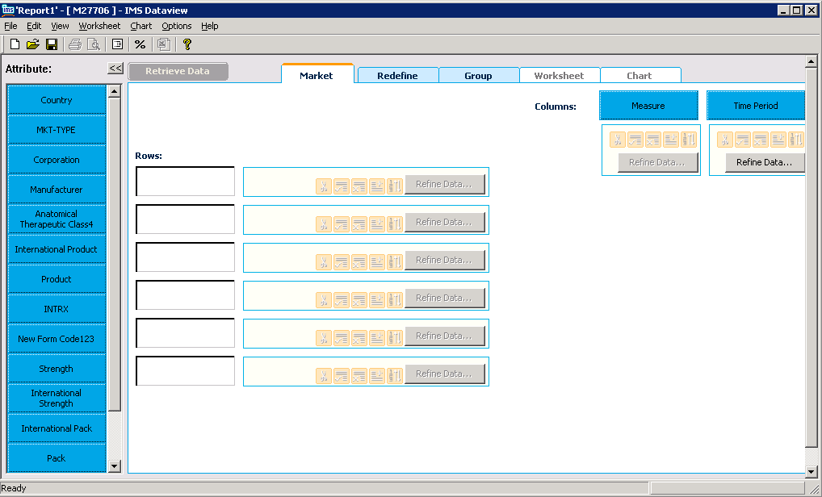
4. | Click “Country”,. Click “Add all” and then “OK”. See screenshot below:
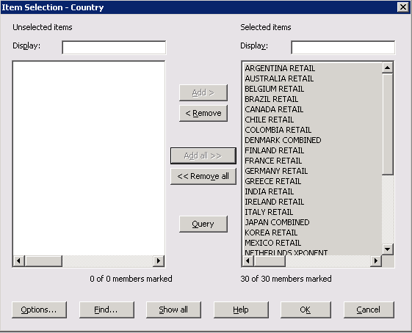
Click “Redefine Data” . Select “Ascending” and “Alphabetic” and click OK. See screenshot below:

 | 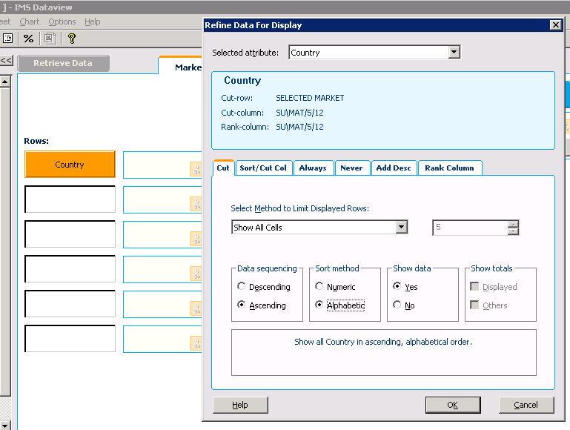
5 | Click “Measure”,. Click “Add all” and then “OK”. See screenshot below:  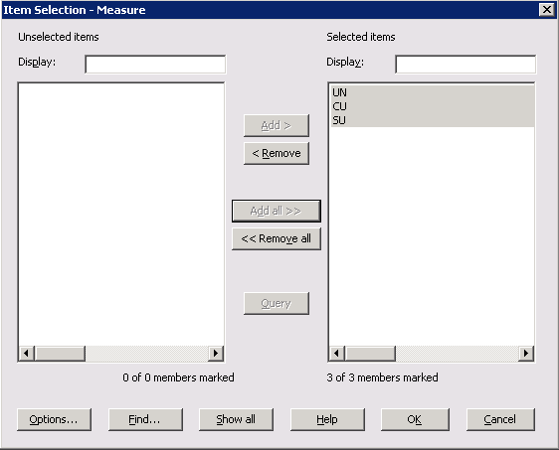
6 | Click “Period”, select MAT1 from the list. Click “Add” and then “OK”. See screenshot below:  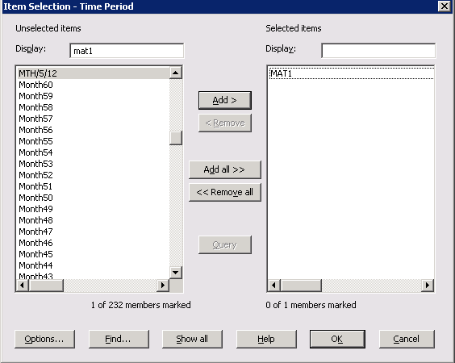
7 | Click “Retrieve data”,. Then copy the value from dataview  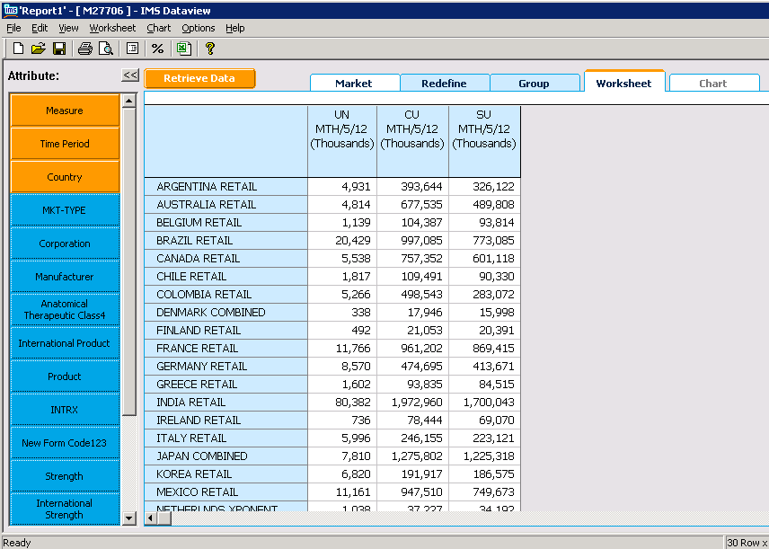  And paste in MAT1 sheet. See the screen short below:  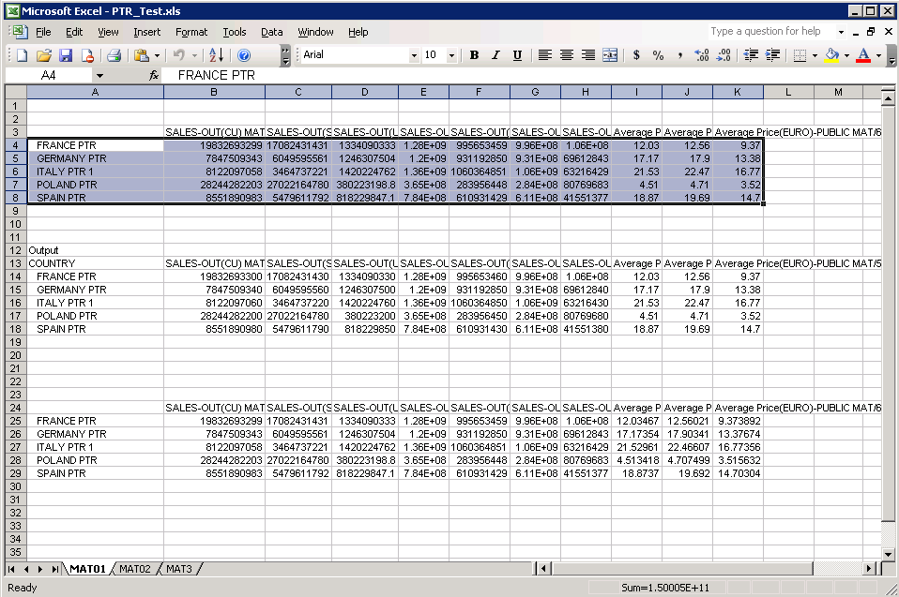
8 | Repeat this for MAT2 , MAT3 and MTH
9 | Open IMS_GALDERMA_PTR_FF_VALIDATION_Mmmyy.XLS
10 | Copy the top portion from PTR_Test.xls and paste the value in dataview portion in IMS_GALDERMA_PTR_FF_VALIDATION_Mmmyy.XLS  Copy the output portion from PTR_Test.xls and paste the value in output portion in IMS_GALDERMA_PTR_FF_VALIDATION_Mmmyy.XLS
11 | Now log on to SQL Server 2005
12 | Run PTR_MTH_QA.sql from D:\CustomData\Galderma_midas_feed\Tools\SQL
13 | Paste result into MTH sheet
14 | Check DIFF page that Diff should be 0.0000%
References
The table below lists other materials that are relevant to this document.
Title | Author | Version | Date | Location

Appendices

Appendix A1: Download FTP Information
Key | Value
FTP Server: | ftp-emea.rxcorp.com
Username: | D08044
Password: | CHProd
Location: | /Level1 PTRi/Client/Respective Month Name

Appendix A2: Download Server Information
Key | Value
Server Address: | 162.44.12.72
Username: | PINASVC-IMAdmin
Password: | !nf0_MgmT

Appendix A3:Processing Server Information
Key | Value
Server Address: | 162.44.22.161
Username: | DACASVC-GDCRDPAdmin
Password: | !nf0_MgmT

Appendix A4: File Express Information
Key | Value
URL: | www.imsportal.com
Username: | ijunaid@bd.imshealth.com or RAlamJoarder@bd.imshealth.com
Password: | B1hanga or centr1n0

